While accessing the application, initially ask for login credentials

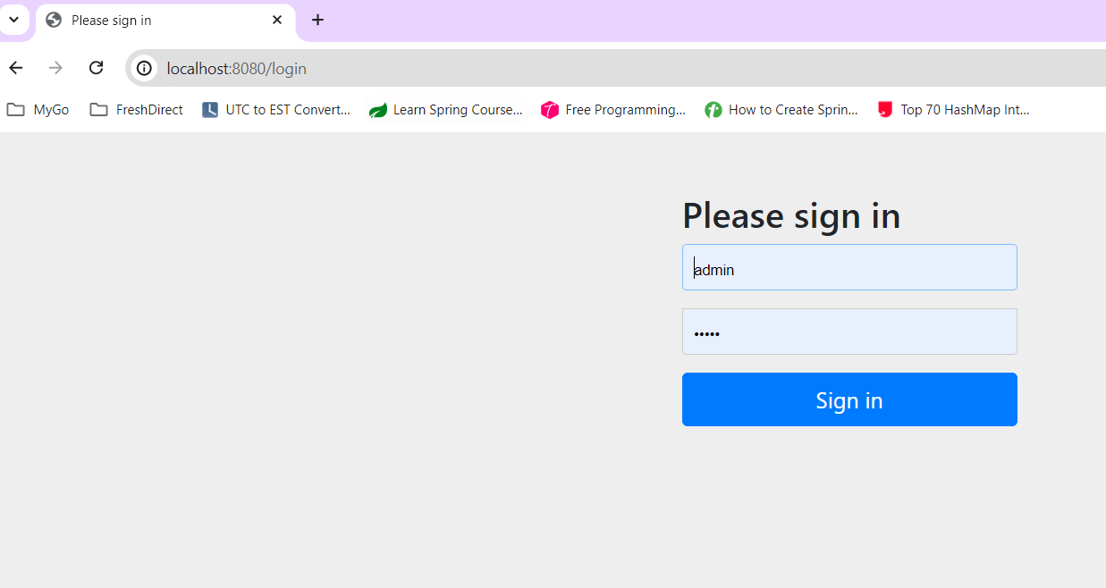

After login the application:

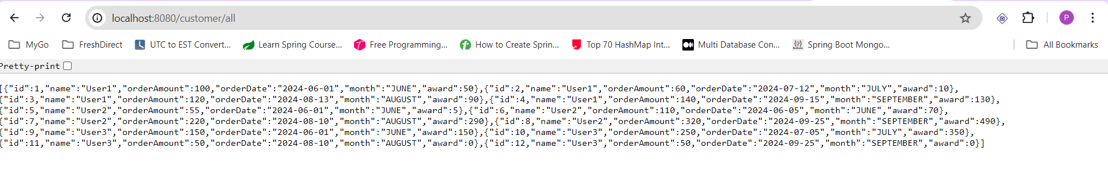

To get specific customer with customer name (http://localhost:8080/customer/find/title/User3)

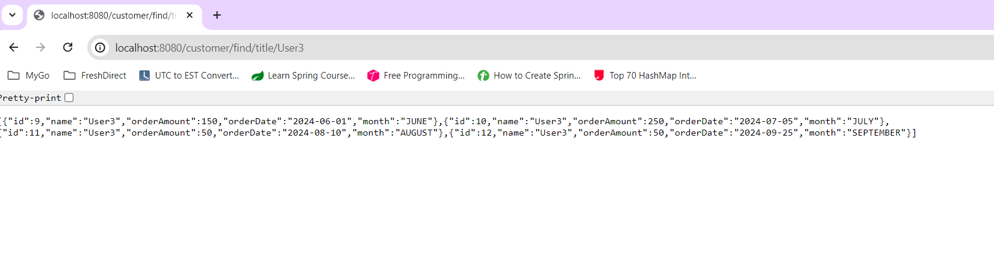

To get the data orders after the provided date

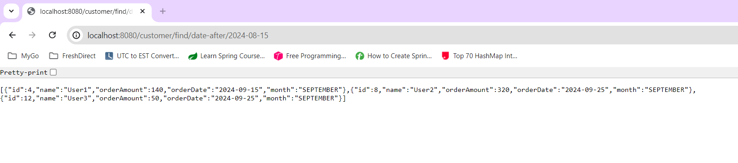

Points report:

Sample Data:

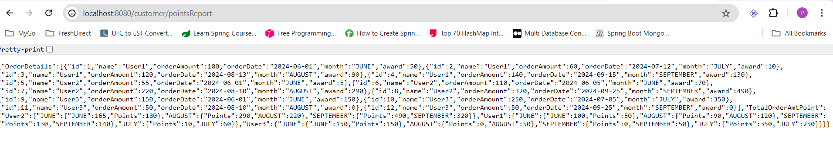

Sample data:

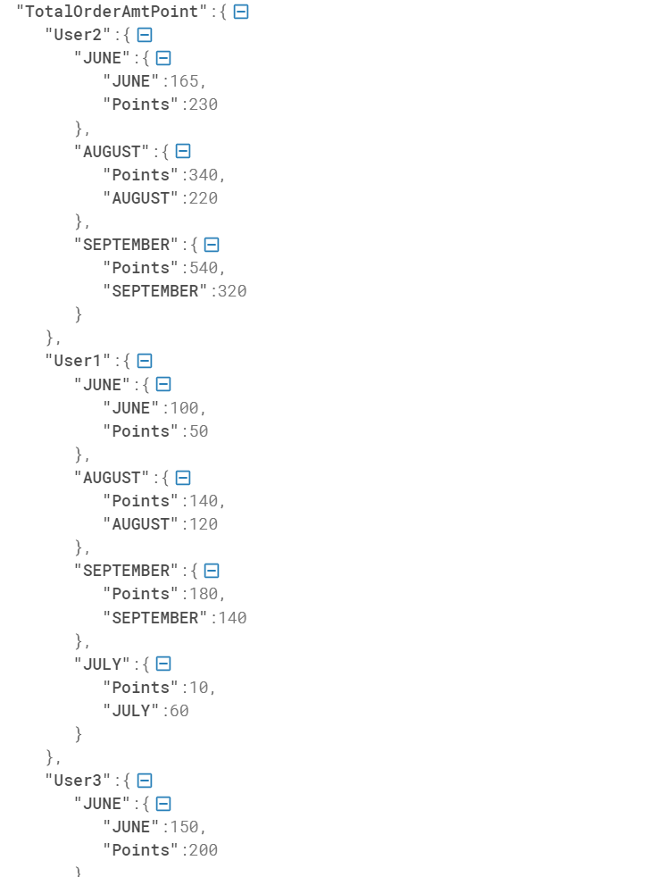

Data after format:

{

"OrderDetails":{

"User2":{

"JUNE":[

{

"id":5,

"name":"User2",

"orderAmount":55,

"orderDate":"2024-06-01",

"month":"JUNE"

},

{

"id":6,

"name":"User2",

"orderAmount":110,

"orderDate":"2024-06-05",

"month":"JUNE"

}

],

"AUGUST":[

{

"id":7,

"name":"User2",

"orderAmount":220,

"orderDate":"2024-08-10",

"month":"AUGUST"

}

],

"SEPTEMBER":[

{

"id":8,

"name":"User2",

"orderAmount":320,

"orderDate":"2024-09-25",

"month":"SEPTEMBER"

}

]

},

"User1":{

"JUNE":[

{

"id":1,

"name":"User1",

"orderAmount":100,

"orderDate":"2024-06-01",

"month":"JUNE"

}

],

"AUGUST":[

{

"id":3,

"name":"User1",

"orderAmount":120,

"orderDate":"2024-08-13",

"month":"AUGUST"

}

],

"SEPTEMBER":[

{

"id":4,

"name":"User1",

"orderAmount":140,

"orderDate":"2024-09-15",

"month":"SEPTEMBER"

}

],

"JULY":[

{

"id":2,

"name":"User1",

"orderAmount":60,

"orderDate":"2024-07-12",

"month":"JULY"

}

]

},

"User3":{

"JUNE":[

{

"id":9,

"name":"User3",

"orderAmount":150,

"orderDate":"2024-06-01",

"month":"JUNE"

}

],

"AUGUST":[

{

"id":11,

"name":"User3",

"orderAmount":50,

"orderDate":"2024-08-10",

"month":"AUGUST"

}

],

"SEPTEMBER":[

{

"id":12,

"name":"User3",

"orderAmount":50,

"orderDate":"2024-09-25",

"month":"SEPTEMBER"

}

],

"JULY":[

{

"id":10,

"name":"User3",

"orderAmount":250,

"orderDate":"2024-07-05",

"month":"JULY"

}

]

}

},

"TotalOrderAmtPoint":{

"User2":{

"JUNE":{

"JUNE":165,

"Points":230

},

"AUGUST":{

"Points":340,

"AUGUST":220

},

"SEPTEMBER":{

"Points":540,

"SEPTEMBER":320

}

},

"User1":{

"JUNE":{

"JUNE":100,

"Points":50

},

"AUGUST":{

"Points":140,

"AUGUST":120

},

"SEPTEMBER":{

"Points":180,

"SEPTEMBER":140

},

"JULY":{

"Points":10,

"JULY":60

}

},

"User3":{

"JUNE":{

"JUNE":150,

"Points":200

},

"AUGUST":{

"Points":0,

"AUGUST":50

},

"SEPTEMBER":{

"Points":0,

"SEPTEMBER":50

},

"JULY":{

"Points":400,

"JULY":250

}

}

}

}